Downloading Your Portfolio from E*Value

Log in to E*Value
Click MyFolio
Go to MyFolio Tools
Click Download MyFolio

Use the following steps to complete your download:

Click here to save your portfolio.

Microsoft Internet Explorer:
Upon clicking the link above, you may be asked whether you want to Open, Save or Cancel.
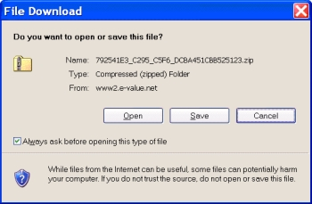
Please choose Save. Doing so will open a dialog box that allows you to browse your hard drive and choose a place to save the zip file.
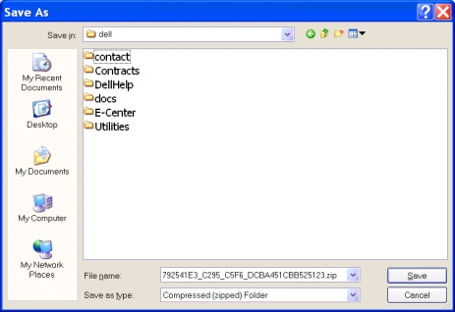
Choose the location to which you would like to save the file and click Save.
Once the file has been saved, you will want to unzip the file in order to make it usable. You can do this by right clicking on the file and choosing Extract. Or you can click into the file and then choose File/Extract All. Either option will open an extract wizard that allows you to extract all of the files so they are in a useable format.
Please note that once the portfolio has been downloaded and extracted, as you click into various pages you may get an alert active content is being blocked. To allow the portfolio to work properly you should change your settings to allow this blocked content. This will not harm your computer in any way, but it will allow for a more robust viewing experience.

Mozilla Firefox and Google Chrome:
Upon clicking the "Download MyFolio" link, you will be directed to click "OK" to save your portfolio as a compressed (zipped) file.
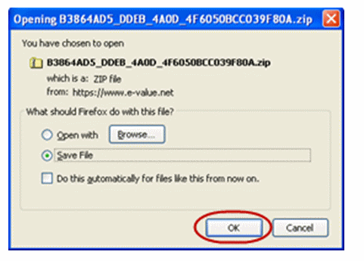
The file will be downloaded to your computer - usually to a temporary file area. Right-click the file or double-click the compressed/zipped to open it.
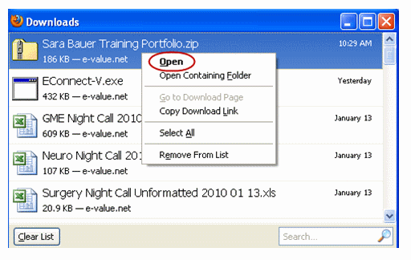
If you open the zipped file, you will see a list of compressed folders that need to be extracted before being viewed.
Compressed files are not hyperlinked. The photo of the portfolio owner will not be displayed. Links to documents and folders will not work. A compressed document looks like this:
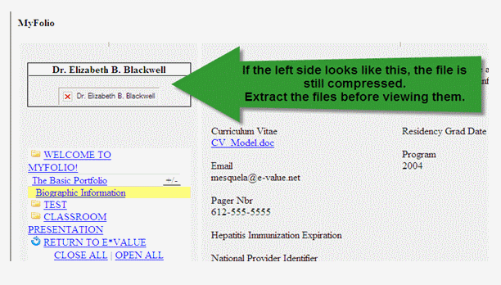
After opening the compressed/zipped folder, click the "Extract All Files" link.
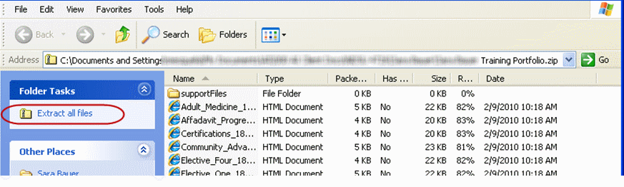
You may want to browse your computer , create new files and store the unzipped files in a more permanent location. Before clicking "next" and extracting the files.
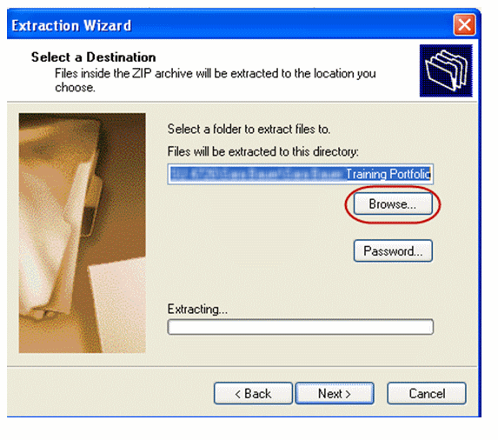
If you click the browse button, create new files as needed and identify a location for the extracted files; then, click "OK".
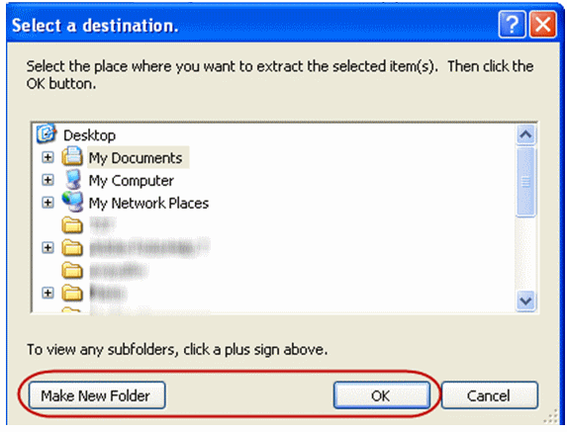
After the files have been extracted, click any file to begin reviewing the portfolio. If there is a folder named after the training program or institution, we recommend opening the portfolio by clicking this folder.

